[Document title] Business Plan
Erin Clark
[Date]

Contents
Using this document 2
Executive summary 3
Business overview 4
Business profile 4
Who we are – our vision and mission 4
Where we are headed – business goals 4
How we will get to where we want to be – our strategy 5
Background 6
Market research and analysis 6
Risk and opportunity assessment 6
Customer 7
Products and services 8
Operations 9
Producing products and services 9
Our people 9
Our technology 10
Finance and legal 11
Our financial position 11
Licences, registrations, permits and insurance 11
Intellectual property 12
Future growth 13

Using this document
why do i need a business plan?
We get it. This template is scary with all of its sections and text and you haven’t even started writing it in yet. It is worth the effort because:
- It will help you work out what you need to do right now and what can be put off until after your launch.
- You’ll need it if you want to get finance from a bank or other investors.
- The money stuff is important. You can be realistic about how you will manage it.
- Having all of your customer stuff written down will make developing your marketing and sales stuff much easier.
- It will give you things to celebrate on your journey between now and launch.

how to approach this
We get that Business Plan writing isn’t the best fun that everyone can have. For most businesses, it would be difficult to sit and write a whole plan in an afternoon. A great business plan takes time. It needs research, interaction with potential customers and a prototype product or service to refine what you plan to sell.
We have been there, done it and got the t-shirt. Here’s some of the things that we have learned:
- This template is a guide only. So depending on your business type or intended audience, you might want to delete (or add) sections.
- Don’t lose sight of why you want to start your own business. Stay motivated.
- Don’t be afraid to get excited. Your business idea is a great one. Just be open to tweaking it as needed based on what your potential customers tell you.
- Ask for help – an expert do in an hour what make take you days and weeks.

the ignitzee fast start framework
We weren’t joking when we said that there should be a lot that comes before this. This is the ‘Focus’ step, four of five. Don’t try to do it all at once – this bad boy is designed to bring together weeks (and potentially months!) of thinking about your business idea, your customer and what you will offer.
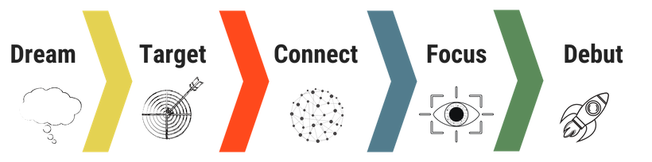

making it pretty
- Using styles – we know that burnt orange isn’t for everyone. Changing the Styles section will change all of the colours and fonts throughout the document.
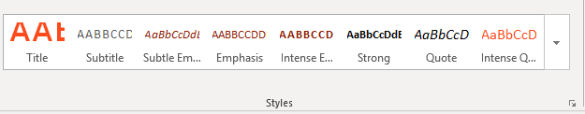
- Remove help text – anything surrounded in a square bracket [text] is there to be helpful and should be removed once you have finished your Business Plan

need help?
Don’t be hard on yourself. Writing a Business Plan isn’t easy. We have boffins who spent years at Business School, got their Accounting qualifications, fell in love with the written word and learned lots about technology so that you do not have to.

Executive summary
current position
[Describe where you are today – how long have you been working on starting your business? What have you achieved so far?]

growth plan
[What’s next? How do you plan to grow what your business offers and its customers?]

Business overview
This section provides an overview of your business describing who are you are and where you are headed.

Business profile
Registered business name | [The hardest bit! ]
Key contact | [Your contact details go here. Don’t forget that sexyguy1980@hotmail.com isn’t the best contact if you are trying to be a serious business person.]
Business structure | Describe whether you have / plan to create a company, partnership, sole trader or family trust. If you aren’t sure what to use here, try our Business Structure Finder tool.
ABN | [Enter your Australian Business Number ABN. You will need one of these regardless of whether you are charging for GST or not.]
GST Registered | [Yes / No]
ACN | [You only need this field if you have a registered company]
Website | [Quick – make sure that you buy your domain before it disappears]
Social media | [Include details for all business social media accounts that apply – LinkedIn; Facebook; Twitter; Youtube; Instagram; Pinterest]

Who we are – our vision and mission
[Each of these sections below should be no more than a sentence in length and will form an important part of your marketing. if you aren’t great with words, we suggest that you get a copywriter to help you as this will form an important part of your materials in the future. This should be an extension of your Customer Value Proposition and your Business Model on a Page.]
Why we exist
[text here]
What we do
[text here]
How we do it
[text here]
How we work with customers
[What makes your customer experience different?]
Why we do what we do
[text here]

Where we are headed – business goals
our vision
[This is the ‘big goal’ identified in the Goal Setter Tool. It describes what you hope your business will become – you might want to be the biggest, have the happiest customers, best quality, to have great work/life balance. ]
short term goals
[The table below should summarise detail outlined in your Goal Setter Tool. Short term goals are those that you will achieve in the next three months that act as milestones for launching your business. Don’t forget to also capture the benefits, obstacles, potential solutions, steps and support needed to achieve your goals in your Fast Start Workbook – that’s what really helps the rubber hit the road.]
Short term goal | Target date
Long term goals
[The table below should summarise detail outlined in your Goal Setter Tool Long term goals are those that you will achieve in the next six to twelve months that will measure the success of the launch of your business. The rest should be in your Fast Start Workbook]
Long term goal | Target date

How we will get to where we want to be – our strategy

what makes us different?
[This should be based on your competitor analysis, describing why a customer would choose your business over that of your competitors.]

start up roadmap
[This is your plan of attack for launching your business. Think of it as a roadmap that outlines the practical steps, you’ll take to get your business from where it is now, to where you want it to be. And the resources you’ll need to do this. It is much easier if you break into sections – we use Operations; Customer; Produce Development; Strategy and Marketing; Finance and Legal] 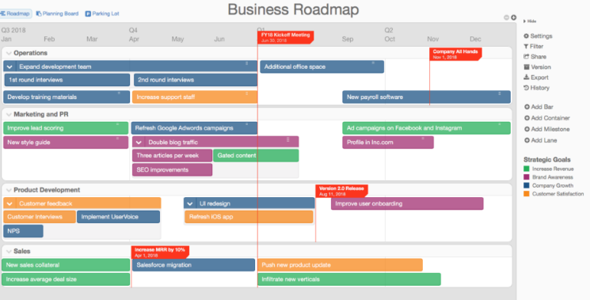
Example Only

Background

Market research and analysis

the opportunity
[This section should summarise the Background Analysis – How will we compete against others section of the Strategy Analyzer Tool. It should describe the gap in the market that your business idea plans to take advantage of]

market structure, size and outlook
[This section should summarise the Market Overview section of the Strategy Analyzer Tool. Here you should place all the relevant stats to describe the market. Your readers need to know how big the market is in consumer/business numbers, as well as the potential value of the market coming from spending habits. Don’t think about how things are today but also trends in the future that could either help or harm the growth of your business. This should be backed up by specific statistics where possible.]

the industry
[Provide a brief overview of the industry in which your business will operate. This is summarised in the Strategy Analyzer Tool. You should consider where your business fits into the relevant marketplace or supply chain and how you plan to be different to the traditional industry structure.]

competitors
[This section should detail top competitors, their pricing strategies, strengths and weaknesses. This is based on the Competitors section of the Strategy Analyzer Tool.]

Risk and opportunity assessment
[This section should summarise the Risks and Opportunities identified in the Strategy Analyzer Too.l]

Customer

customer value proposition
[You may wish to describe one value proposition for the business idea as a whole or multiple customer value propositions, one for each of your target customer segments. This is first identified in the Dream Starter tool as part of the potential problem or opportunity that your business might solve and then formalised in the Customer Value Proposition Explorer tool].

target customer segment(s)
[These are first identified in the Dream Starter tool as part of the Understanding your customers section. It is then summarised in the Customer Value Proposition Explorer Tool. Your description of your target customer segment(s) may be in the form of attributes e.g. location, socio-economic status or as a persona.]

launch approach
[This section should be your initial thinking about how you are going on attract new customers. This includes reflecting on how customers will know that your business is available as an option and how you will encourage them to switch to your products and services. Your launch approach should be further detailed in the next phase, Debut.]

Products and services

product offering
[Describe the products and/or services that your business will offer initially, including specific features. These are first identified in the Dream Starter Tool within the Understanding your product section.]

pricing strategy
[Revenue streams are brainstormed the Business Model Canvas tool; pricing strategy is identified in the Strategy Analyzer Tool and your indicative prices entered into the Finance Workbook. This section should discuss your assumptions behind your pricing – why have you decided on a specific cost structure.]

Operations

Producing products and services

key activities
[The key steps associated with producing your products and services are identified in the Customer Value Proposition Explorer].

locations and outlets
[Detail any locations or outlets associated with either producing or selling your products and services. This includes shop fronts, factories, co-working spaces or home-office set-up. Explain the advantages of your business’s location(s). For example, retailers need locations with great foot traffic, while manufacturers are better to be near freight transport links.]

key partners
[Describe the key external parties that you will need to deliver on your business idea. Key Partners are identified in the Business Model Explorer Tool.]

channels
[Detail how you will connect with customers and distribute your products and services. Channels are identified in the Business Model Explorer Tool.]

key resources
[Provide a high-level view of the things that are under the direct control of your business that will add to its value – think about intangible assets like brand as well as physical assets like equipment. Key resources are initially identified in the Business Model Explorer. A full list of your plant, equipment and inventory should be included in your Financial Workbook.]

Our people

our team
[Describe your management structure and key roles. You may wish to separate this out between the people that you’ll need to get your business idea off the ground versus those that you will need to run the business. Think about how you will cover technical, logistics, marketing, business development, sales, customer service, service delivery/manufacturing and human resources activities.
If you are a solopreneur, this section should detail your specific skills that you have, the skills that you need to build and how you will get there. Refer to the ‘Skills you will build’ and ‘Others that will help you’ sections in the Goal Setter Tool for inspiration.]

attracting and keeping the right people
This section details how you will make sure that you get and keep the right people to help with your business
Attract (Recruitment) | [How do you plan to recruit the required staff? Are there any potential skill shortages that may impact on your ability to recruit the appropriate people?]
Training | [What skills do you need to develop for yourself and others? How will you build them?]
Retention | [How will you keep the team engaged?]

our support team
[Describe any mentors or business support resources that you plan to leverage. Refer to the Support team identified in your Goal Setter Tool. You may also wish to note any contracts or other legal arrangements, such as Non-Disclosure Agreements that you will need to have in place with your partners.]

Our technology
[How do you plan to use technology, including the internet and cloud solutions? Consider how you will connect with customers, produce products and services and manage your business day-to-day. This is identified in the Technology Needs Assessment]]

Finance and legal

Our financial position

start up costs
[Insert the Start Up Costs tab from the Financial Workbook]

start up funding
[This is first identified in the Dream Starter Tool as part of the Understanding your investment section and updated in the Start Up Costs tab in the Financial Workbook]

financial analysis
[Insert the Summary tab from the Financial Workbook]

Licences, registrations, permits and insurance
[List all the licences, registrations and insurances your business is required to have in order to operate. These may include registering a business name; high risk work licence; domain name; trademark registration; etc. Online tools are available from your state government small business department to help determine which licences and permits you need.]
Licence/  Registration | Cost ($) | Expires | Supplier | Website
Business name registration | $35 per year | 30 June XXXX | ASIC | www.asic.gov.au

Type of insurance | Cover ($) | Broker or agent | Contact person | Phone | Email
Public liability | $5 million | ABC Insurance | Jim Smith | 9222 2222 | jim@abcinsurance.com.au

Intellectual property
[This focuses on how you will prevent others, where appropriate, from copying what makes your business unique so that you can stay competitive. This may include copyright protection, trademarks, trade secrets and patents.]

Future growth
This section describes the future growth of your business that haven’t been specifically included in the costs or plans in the Business Plan so far.

customer / the opportunity
[What additional geographic or additional customer segments might your business expand to? Include specific target dates if known]

products and services
[What additional products or services could you provide to take advantage of the customer opportunity outlined above?]

operations
[How might you grow the operations of your business?]
People
Technology
Equipment

