[Document title]
Fast Start Workbook
Your Name
[Date]

Contents
How it works 2
Dream 4
1.1 Fast Start Plan 4
1.2 Goal Setter Tool 5
1.3 Dream Starter Tool 6
Target 7
2.1 Customer Value Proposition Explorer 7
2.2 Customer Understanding checklist 8
Connect 9
3.1 Profitability Explorer Tool 9
3.2 Business Model Explorer Tool 10
3.3 Business Model on a Page 10
3.4 Business Feasibility Checklist 10
Focus 11
4.1 Strategy Explorer Tool 11
4.2 Technology Needs Assessment 11
4.3 Business Structure Finder 11
4.4 Finance Workbook 11
4.5 Business Plan 12
4.6 Business Plan Checklist 12
Debut 13
5.1 Product Launch Plan 13
5.2 Start Up Launch Planner Tool 13
5.3 Visual Identity Planner tool 13
5.4 Launch Checklist 13

How it works
This document is designed to keep all of your great thinking on one place as you work towards starting your own business. Don’t be afraid to add extra notes and sections as you need.
Getting started
We suggest that you have:
- Somewhere reliable to keep this document (the cloud isn’t just for Monkey Magic. It’s also a good place to store documents. You may want to consider Google Drive, Microsoft OneDrive or DropBox).
- A separate tool for tracking tasks and setting deadlines as you go
- A sense of humour and adventure
- A computer to call your own (using a work laptop can cause you intellectual property issues and just makes life confusing)
using the fast start framework
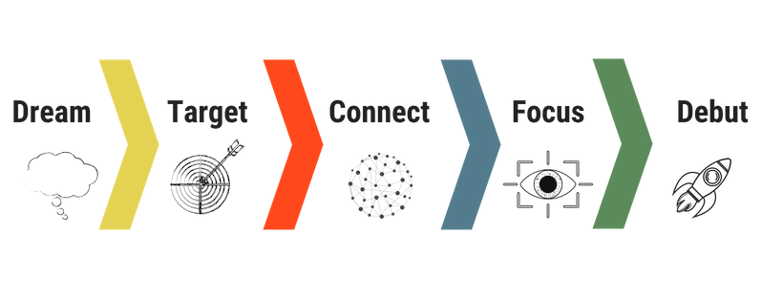
Your journey from dreaming to doing is broken into five stages. There are then steps within each stage. We have numbered them to make things easier to follow. But we know that life doesn’t always go in a straight line. You can skip any tools that you aren’t “feeling”. But don’t think that you can get out of hard work – many of the tools build on one another.
 | Tools | Each tool walks you through a specific step to start your own business. At the end, you receive a summary that can be included in your plans. These are accessed via the Ignitzee website subscribers’ section.
 | Templates | The templates bring together what you create in each of the tools so that you can share your great business idea with the world. These are accessed via the Ignitzee website subscribers’ section.
 | Specialist tools | These tools require the involvement of Ignitzee specialists. Access to specialist advice is included in most packages. Otherwise, it can also be included for an additional one-off fee. Contact hello@ignitzee.com.au for more information.
 | Coaching | This shows the recommended point for coaching with the Ignitzee team. Coaching is included in the premium monthly subscription and most packages. Contact hello@ignitzee.com.au to schedule coaching sessions.
 | Checklist | These provide a series of Yes / No questions that checks that you have all of the basics in place before moving onto the more complicated (and scary!) stuff. These are accessed via the Ignitzee website subscribers’ section.

Dream
Explore your business idea. Understand what type of entrepreneur you'll be. Make plans to set your work on fire.

1.1 Fast Start Plan
[That’s this section right here. If you put your name on the front page, you are already a winner . The next step is to make a rough plan about how and when you are going to start your business. It’s only day one so keep it simple. The table below is included as a guide only. We recommend that you use planning software, such as Microsoft Planner, so that you can track your progress towards starting your business. Our boffins love matching people with the right technology if you need a hand.]
STAGE | KEY ACTIVITIES | Wk 1 | Wk 2 | Wk 3 | Wk 4
Dream | Set goals (1.2, 1.3 & 1.4)
Target | Understand customer (2.1 & 2.2)
Connect | Develop early prototype
 | Understand business model (3.1, 3.2, 3.3, 3.4)
Focus | Understand strategy and competitors (4.1)
 | Understand technology needs, business structure and forecast finances (4.2, 4.3 & 4.4)
 | Develop business plan (4.5 & 4.6)
Debut | Plan launch (5.1 & 5.2)
 | Develop visual identity – web, logo etc. (5.3)
 | Develop products and services and prepare for launch (5.4)

1.2 Goal Setter Tool
where you are headed
[Paste the output from the Fast Start Planner here – Your Big Goal; Why it’s important; This Week’s Goal; This Month’s Goal]
We have included extra tables here for you to add more goals as you need them – it might be this week, this month or this year.
Goal
Benefits of achieving
Obstacles
Potential solutions

Steps to achieve
Support needed
Target date

Goal
Benefits of achieving
Obstacles
Potential solutions

Steps to achieve
Support needed
Target date

your dream team
[Paste the output from the Fast Start Planner here – Skills you will build; Other that will help you; Your Support team]

getting there and getting my sh*t together
[Paste the output from the Fast Start Planner here – When I’ll work; Where I’ll Work; How I’ll Track Progress; How I’ll measure success; How I’ll hold myself to account; How I’ll celebrate the launch; Things I’ll start doing; Things I’ll drop doing; Distractions I’m going to avoid]

1.3 Dream Starter Tool
[Paste the output from the Dream Starter Tool here – Understanding your customers; Understanding your Product; Understanding your investment.]

Target
Understand your customers and what they want. Explore how you will provide value for customers.
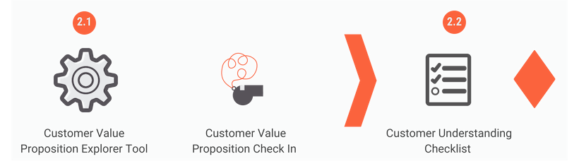

2.1 Customer Value Proposition Explorer
customer value proposition
[Paste your customer value proposition statement from Customer Value Proposition Explorer - Section D here. Don’t forget to tidy up your grammar if sounds a little strange. This is something that you will use over and over again as you start your business. If it still doesn’t sound right, we suggest that you grab a copywriter to help you.]

products and services
[This is your Product Definition – customer steps, ‘Must Have’ / ‘Should Have’ / ‘Could Have’ features]

product roadmap
[If you don’t already have products and services that are ready for your customer launch, you’ll need to make sure that you finish developing them. The table below is designed to give you some ideas about the milestones and tasks to track. Double-clicking it will open it in Excel. Don’t forget that a planning tool is best.]

2.2 Customer Understanding checklist
[Note here anything that you haven’t finished yet that you marked as ‘No’ that you want to follow up later]

Connect
Sense check that all of the dots of your business idea connect - what your customers want and how it will make money.
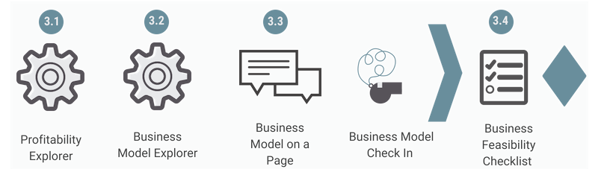

3.1 Profitability Explorer Tool
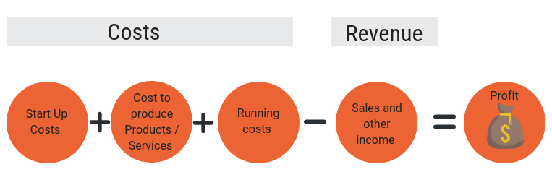
profitability reflection
[Paste the output from the Profitability reflection into the table below. You will need to double-click on the table for it to open in Excel. It uses the calculation > Estimated average annual profit = ((Average Sales Revenue Per Customer Transition - Average Production Cost) x Average Customer Transactions per Year))
cost structure
[Paste the output from the What you’ll need for your Business Plan on a Page – Cost Structure here]
revenue streamS
[Paste the output from the What you’ll need for your Business Plan on a Page – Revenue Streams here]

3.2 Business Model Explorer Tool
[Paste the output from Business Model Plan on a Page here. If you want something fancier, you can always summarise it in the Business Model template in PowerPoint]

3.3 Business Model on a Page
[A pretty version of your Business Model on a Page can be included using this template]
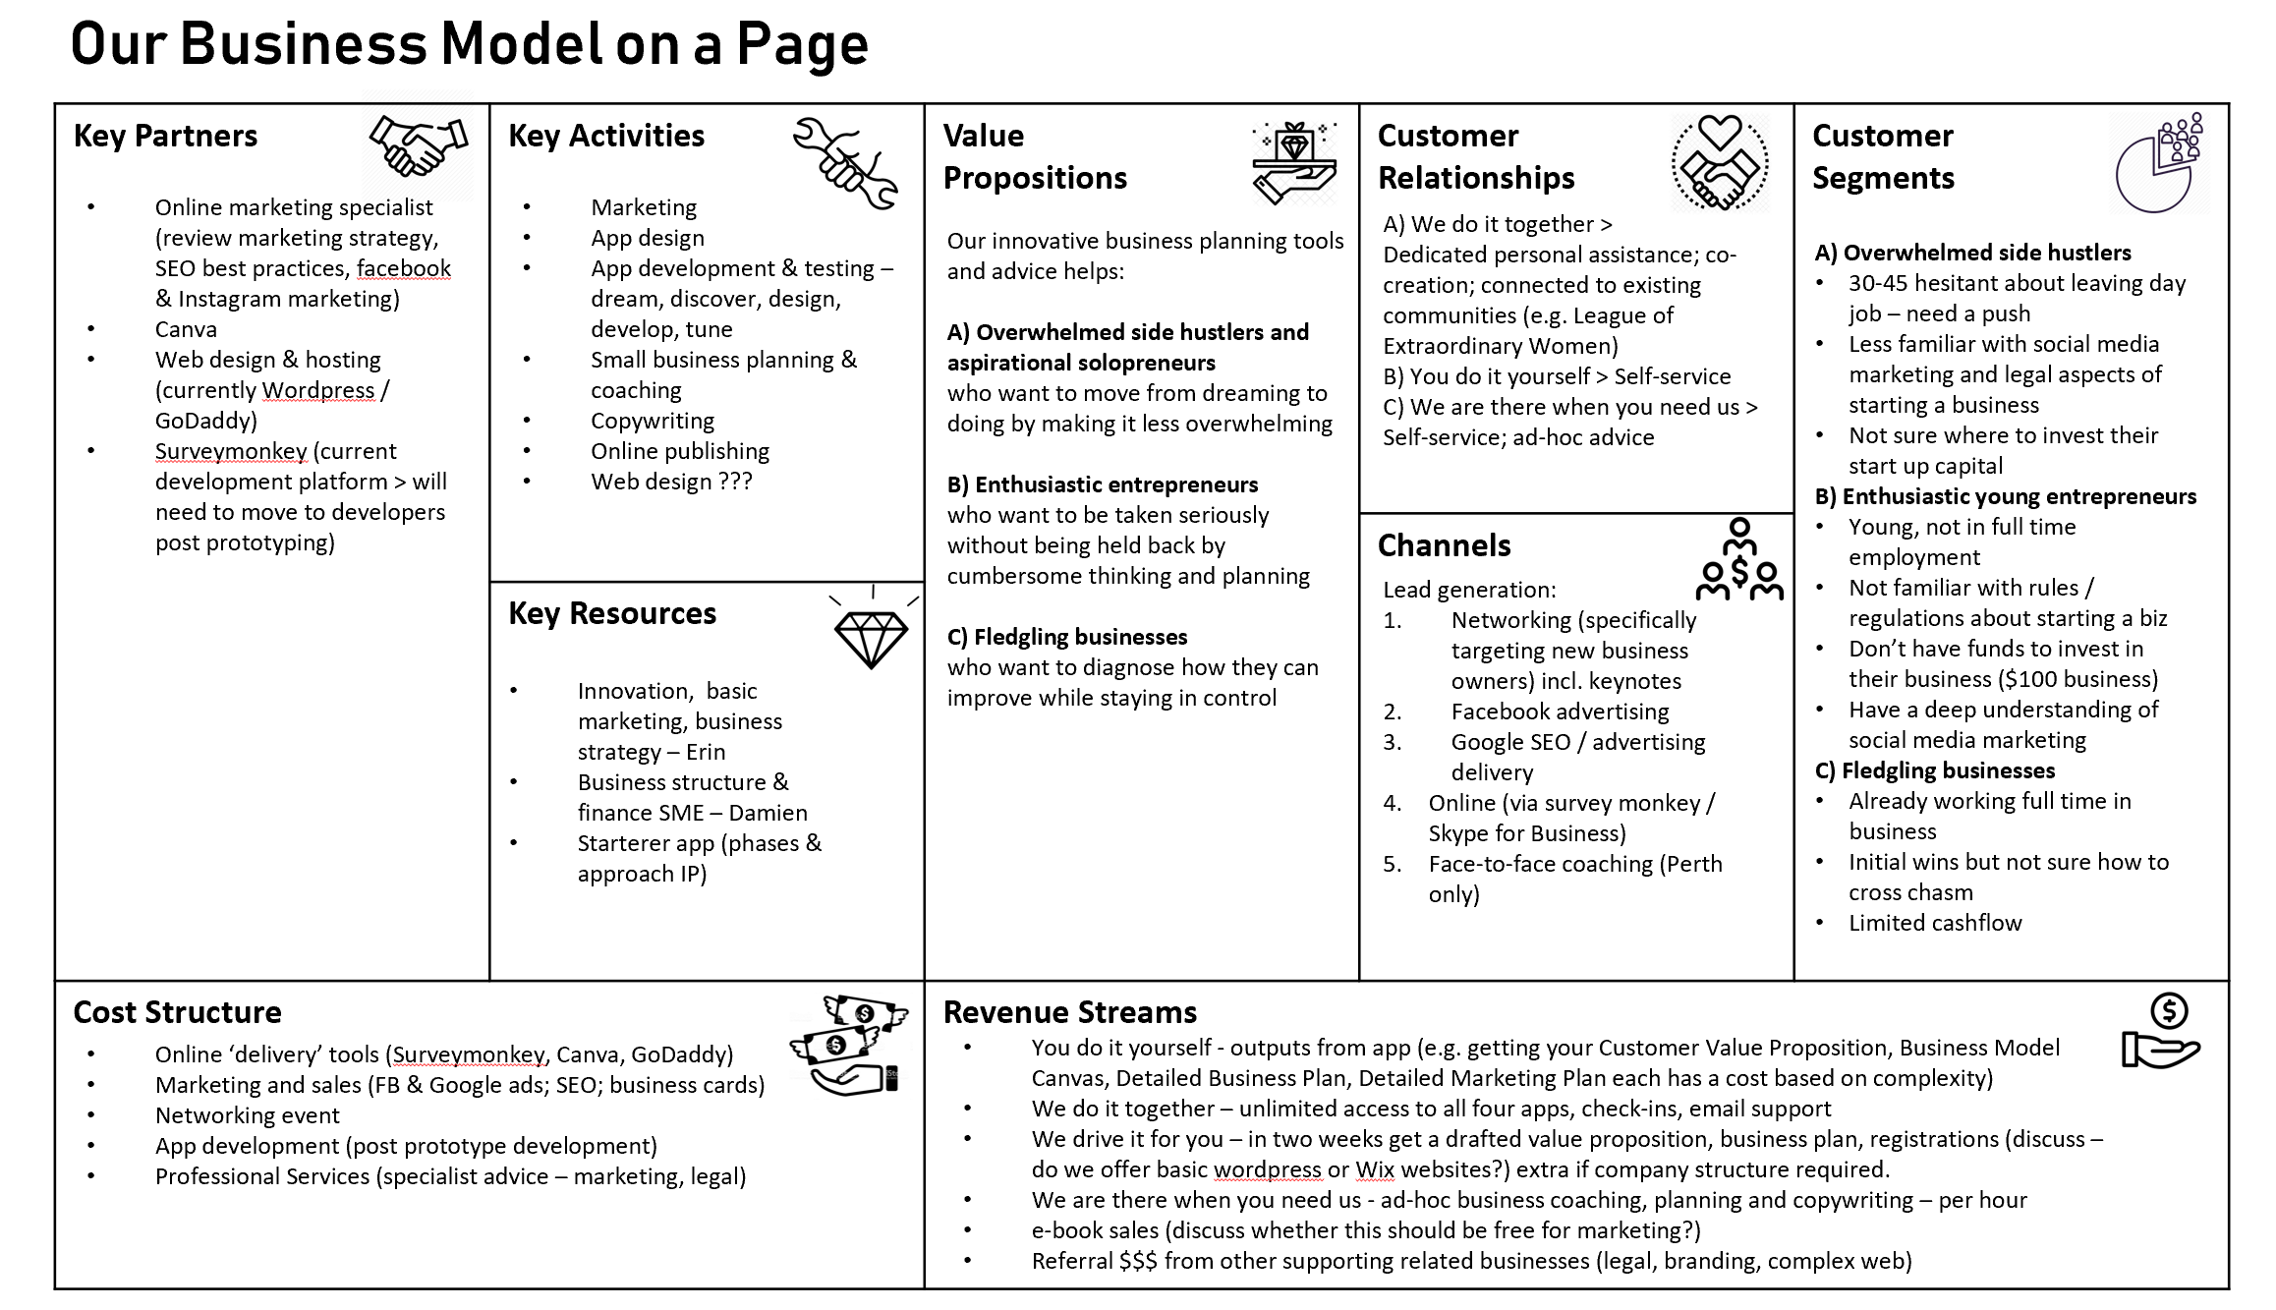
Example Only

3.4 Business Feasibility Checklist
business model insights
[Paste outputs from the Next Steps page here – further investigation; top priorities and support resources needed here]
[The table below has been included to capture any additional activities that you need to follow up on following the Connect stage – please remove if you are using a separate application to track your To Do list]
Activity | By Whom | By When | Status

Focus
Identify what you need to bring your dream into reality - who, what, how and how much before you make an investment.
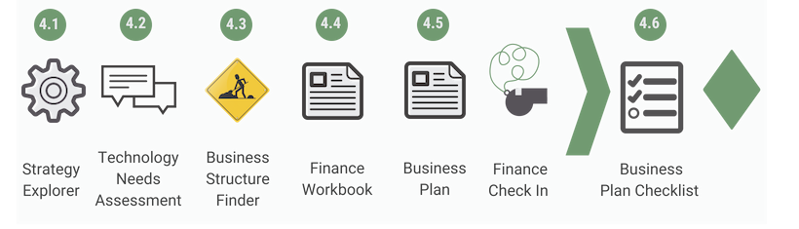

4.1 Strategy Explorer Tool
[The outputs from this tool are designed to be pasted into the background section of the Business Plan template. You can also paste them here if you want to make sure that you don’t lose them.]
[The table below has been included to capture follow-up activities identified in the Action Plan – please remove if you are using a separate application to track your To Do list]
Activity | By Whom | By When | Status

4.2 Technology Needs Assessment
[The Technology Needs Assessment is a specialist product. It starts with you completing the online tool. Our boffins then send you a recommended roadmap. We suggest that you include a link to the completed roadmap here. If you are flying solo on this part, you can use this section of the Workbook to outline the technology that your business will need for start-up and costs.]

4.3 Business Structure Finder
[Business structures are complicated. We are still testing our tool to help you find the right one. Contact us to be part of a free pilot.]

4.4 Finance Workbook
[The finance workbook keeps all of your information finance information in the same place. Include a link to where it is stored here so that you don’t misplace it. We have included a summary table below should you need to capture key information]
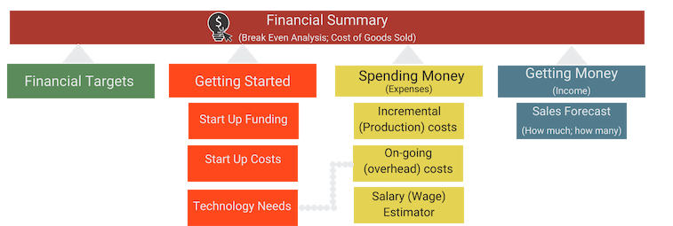
Forecast | Relevant information
Start Up Funding
Start Up Costs
Technology Needs
Incremental (Production) Costs
Salary (Wage) Estimator
Sales Forecast

4.5 Business Plan
[We suggest that you include a link here to where you have saved your Business Plan so that it is easy to find]

4.6 Business Plan Checklist
[The table below has been included to capture any additional activities that you need to follow up on following the Focus stage – please remove if you are using a separate application to track your To Do list]
Activity | By Whom | By When | Status

Debut
Put in place the right processes, people and technology to start attracting customers and living your dream.
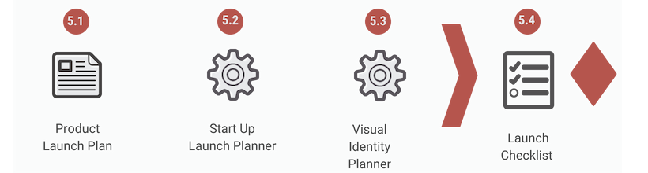

5.1 Product Launch Plan
[Include a link to your Product Launch Plan here.]

5.2 Start Up Launch Planner Tool
[Paste your outputs from the Action Plan here – Brand Story; Customer Journey; Launch Goals and Next Steps.]

5.3 Visual Identity Planner tool
[Paste your outputs from the Action Plan here – Visual Identity; Dream Team; What Is Needed.]

5.4 Launch Checklist
[Note here any questions that you answered ‘No’ that you will need to follow up on later. Don’t forget to celebrate your achievement – you are amazing!]

